Computer Language Coding Concepts

Controlling a Related Object in a Diagram
The concept of controlling a related object is explained in the article Controlling a Related Object. The current article demonstrates it in a diagram.

A related object is a controlled object reference, wrapped inside a → related item or inside a →n related list item.

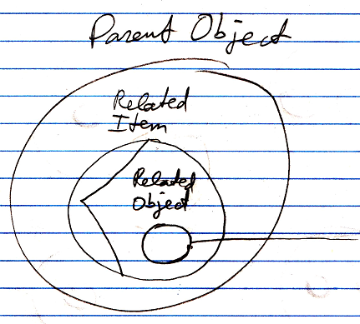

See also: System Objects, Controlling a Related Object

Author & Copyright: Jan-Joost van Zon Date: June 18, 2008 – June 18, 2008 Location: Oosterhout, The Netherlands Status: Finished

